25.9.20 Editors - Properties Editor - Particle Properties Tab - Force Field Settings panel
Force Field Settings panel 4
Self Effect 4
Effector Amount 4
Type 1 and Type 2 Sub panels 4
Type 1 / 2 4
Force 4
Strength 4
Flow 4
Affect 4
Location 4
Rotation 4
Noise Amount 4
Seed 5
Gravitation 5
Absorption 5
Wind Factor 5
Wind 5
Strength 5
Flow 5
Affect 5
Location 5
Rotation 5
Noise Amount 5
Seed 5
Absorption 5
Wind Factor 5
Vortex 6
Strength 6
Flow 6
Affect 6
Location 6
Rotation 6
Noise Amount 6
Seed 6
Absorption 6
Wind Factor 6
Magnetic 6
Strength 6
Flow 6
Affect 6
Location 6
Rotation 6
Noise Amount 7
Seed 7
Absorption 7
Wind Factor 7
Harmonic 7
Strength 7
Damping 7
Rest Length 7
Affect 7
Location 7
Rotation 7
Noise Amount 7
Seed 7
Multiple Springs 7
Absorption 7
Wind Factor 7
Charge 8
Strength 8
Flow 8
Affect 8
Location 8
Rotation 8
Noise Amount 8
Seed 8
Absorption 8
Wind Factor 8
Lenard Jones 8
Strength 8
Flow 8
Affect 9
Location 9
Rotation 9
Noise Amount 9
Seed 9
Absorption 9
Wind Factor 9
Texture 9
Strength 9
Flow 9
Affect 9
Location 9
Rotation 9
Noise Amount 9
Seed 9
Absorption 9
Wind Factor 10
Curve Guide 10
Strength 10
Flow 10
Affect 10
Location 10
Rotation 10
Noise Amount 10
Seed 10
Absorption 10
Wind Factor 10
Boid 10
Strength 10
Flow 10
Affect 11
Location 11
Rotation 11
Noise Amount 11
Seed 11
Absorption 11
Wind Factor 11
Turbulence 11
Strength 11
Size 11
Flow 11
Affect 11
Location 11
Rotation 11
Noise Amount 11
Seed 11
Global 12
Absorption 12
Wind Factor 12
Drag 12
Linear 12
Quadratic 12
Affect 12
Location 12
Rotation 12
Noise Amount 12
Seed 12
Absorption 12
Wind Factor 12
Fluid Flow 13
Strength 13
Flow 13
Affect 13
Location 13
Rotation 13
Noise Amount 13
Seed 13
Absorption 13
Wind Factor 13
Falloff subpanel 13
Z Direction 13
Power 13
Min Distance 13
Max Distance 13

Force Field Settings panel
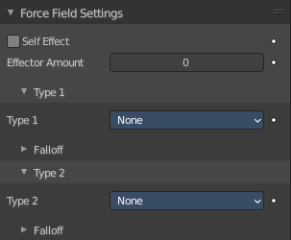
The Force Field Settings panel allows you to make each individual act as a force field, allowing them to affect other dynamic systems, or even, each other.

Self Effect
Causes the particle force fields to have an effect on other particles within the same system.

Effector Amount
Set how many of the particles act as force fields. 0 means all of them are effectors.

Type 1 and Type 2 Sub panels
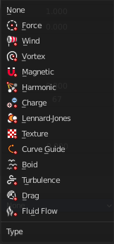
You can give particle systems up to two force fields. By default they do not have any force field enabled. Choose an effector type from the selector to enable them.

Type 1 / 2

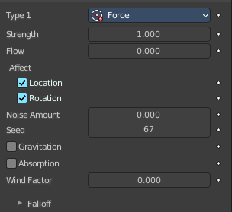
Force
Radial field towards the center of an object.

Strength
The strength of the force.

Flow
Convert effector force into air force velocity.

Affect

Location
Affect the location of the particles.

Rotation
Affect the rotation of the particles.

Noise Amount
Amount of noise for the force effect.

Seed
The random seed for the noise amount.

Gravitation
Multiply force by 1 divided through the distance in square.

Absorption
Force gets absorbed by collision objects.

Wind Factor
How much the force is reduced when acting parallel to a surface. Like a cloth.

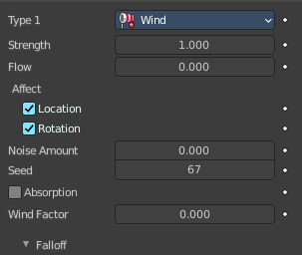
Wind
Constant force along the Z axis.

Strength
The strength of the force.

Flow
Convert effector force into air force velocity.

Affect

Location
Affect the location of the particles.

Rotation
Affect the rotation of the particles.

Noise Amount
Amount of noise for the force effect.

Seed
The random seed for the noise amount.

Absorption
Force gets absorbed by collision objects.

Wind Factor
How much the force is reduced when acting parallel to a surface. Like a cloth.

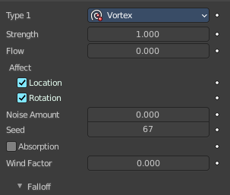
Vortex
Spiraling force that twists the force object's local Z axis.

Strength
The strength of the force.

Flow
Convert effector force into air force velocity.

Affect

Location
Affect the location of the particles.

Rotation
Affect the rotation of the particles.

Noise Amount
Amount of noise for the force effect.

Seed
The random seed for the noise amount.

Absorption
Force gets absorbed by collision objects.

Wind Factor
How much the force is reduced when acting parallel to a surface. Like a cloth.

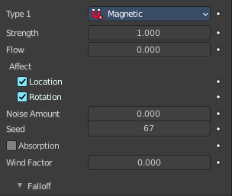
Magnetic
Force field depends of the speed of the particles.

Strength
The strength of the force.

Flow
Convert effector force into air force velocity.

Affect

Location
Affect the location of the particles.

Rotation
Affect the rotation of the particles.

Noise Amount
Amount of noise for the force effect.

Seed
The random seed for the noise amount.

Absorption
Force gets absorbed by collision objects.

Wind Factor
How much the force is reduced when acting parallel to a surface. Like a cloth.

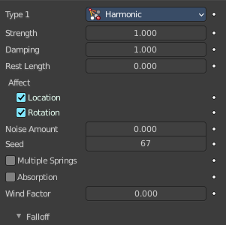
Harmonic
The source of this force field is the zero point of a harmonic oscillator.

Strength
The strength of the force.

Damping
Damping of the harmonic force.

Rest Length
The rest length of the harmonic force.

Affect

Location
Affect the location of the particles.

Rotation
Affect the rotation of the particles.

Noise Amount
Amount of noise for the force effect.

Seed
The random seed for the noise amount.

Multiple Springs
Every point is effected by multiple springs.

Absorption
Force gets absorbed by collision objects.

Wind Factor
How much the force is reduced when acting parallel to a surface. Like a cloth.

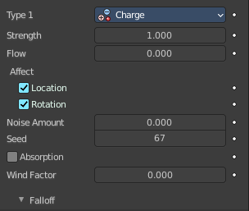
Charge
Special force field based on the charge of particles. Charge force fields just affects other charge force fields.

Strength
The strength of the force.

Flow
Convert effector force into air force velocity.

Affect

Location
Affect the location of the particles.

Rotation
Affect the rotation of the particles.

Noise Amount
Amount of noise for the force effect.

Seed
The random seed for the noise amount.

Absorption
Force gets absorbed by collision objects.

Wind Factor
How much the force is reduced when acting parallel to a surface. Like a cloth.

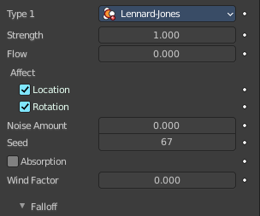
Lenard Jones
Force field based on the lennard jones potential. The Lennard-Jones potential describes the interactions of two neutral particles using a relatively simple mathematical model.

Strength
The strength of the force.

Flow
Convert effector force into air force velocity.

Affect

Location
Affect the location of the particles.

Rotation
Affect the rotation of the particles.

Noise Amount
Amount of noise for the force effect.

Seed
The random seed for the noise amount.

Absorption
Force gets absorbed by collision objects.

Wind Factor
How much the force is reduced when acting parallel to a surface. Like a cloth.

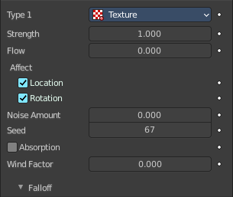
Texture
Force field based on a texture. There is no way to add a texture here though.

Strength
The strength of the force.

Flow
Convert effector force into air force velocity.

Affect

Location
Affect the location of the particles.

Rotation
Affect the rotation of the particles.

Noise Amount
Amount of noise for the force effect.

Seed
The random seed for the noise amount.

Absorption
Force gets absorbed by collision objects.

Wind Factor
How much the force is reduced when acting parallel to a surface. Like a cloth.

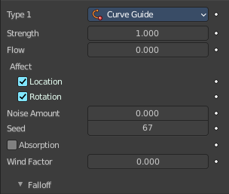
Curve Guide
Creates a force along a curve object. There is no way to add a curve here though.

Strength
The strength of the force.

Flow
Convert effector force into air force velocity.

Affect

Location
Affect the location of the particles.

Rotation
Affect the rotation of the particles.

Noise Amount
Amount of noise for the force effect.

Seed
The random seed for the noise amount.

Absorption
Force gets absorbed by collision objects.

Wind Factor
How much the force is reduced when acting parallel to a surface. Like a cloth.

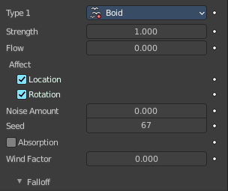
Boid
Creates a force that acts as a boid's predator or target.

Strength
The strength of the force.

Flow
Convert effector force into air force velocity.

Affect

Location
Affect the location of the particles.

Rotation
Affect the rotation of the particles.

Noise Amount
Amount of noise for the force effect.

Seed
The random seed for the noise amount.

Absorption
Force gets absorbed by collision objects.

Wind Factor
How much the force is reduced when acting parallel to a surface. Like a cloth.

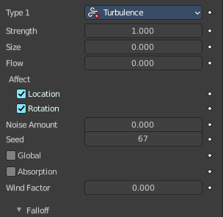
Turbulence
Create turbulence with a noise field.

Strength
The strength of the force.

Size
The size of the turbulence.

Flow
Convert effector force into air force velocity.

Affect

Location
Affect the location of the particles.

Rotation
Affect the rotation of the particles.

Noise Amount
Amount of noise for the force effect.

Seed
The random seed for the noise amount.

Global
Use global coordinates for the turbulence.

Absorption
Force gets absorbed by collision objects.

Wind Factor
How much the force is reduced when acting parallel to a surface. Like a cloth.

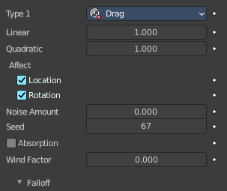
Drag
Create a force that dampens motion.

Linear
Drag component proportional to velocity.

Quadratic
Drag component proportional to square velocity.

Affect

Location
Affect the location of the particles.

Rotation
Affect the rotation of the particles.

Noise Amount
Amount of noise for the force effect.

Seed
The random seed for the noise amount.

Absorption
Force gets absorbed by collision objects.

Wind Factor
How much the force is reduced when acting parallel to a surface. Like a cloth.

Fluid Flow
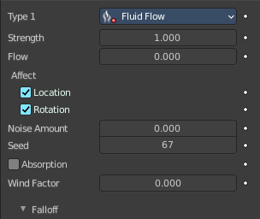
Create a force field based on fluid simulation velocities.

Strength
The strength of the force.

Flow
Convert effector force into air force velocity.

Affect

Location
Affect the location of the particles.

Rotation
Affect the rotation of the particles.

Noise Amount
Amount of noise for the force effect.

Seed
The random seed for the noise amount.

Absorption
Force gets absorbed by collision objects.

Wind Factor
How much the force is reduced when acting parallel to a surface. Like a cloth.

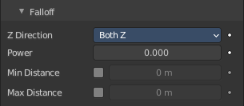
Falloff subpanel

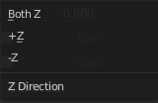
Z Direction
Apply the effect in both directions along Z axis, or just one direction.

Power
How quickly the strength falls off with increasing distance from the force field.

Min Distance
Minimum distance for the fields falloff.

Max Distance
Maximum distance for the fields falloff.

